Clinical Management System

INSTRUCTOR
Dr. Muhammed Elsayeh

MEMBERS
Maya Elfar | 241001528
Haneen Osman | 241002373
Roaa Tamer Ibrahim | 241002475
Menna Tallah Mohamed | 241001967

Conceptual Design:
entity: DEPARTMENT
attributes: department_ID (primary key), name
entity: CLINIC
attributes: clinic_ID (primary key), name, address, [department_ID as foreign key]
entity: DOCTOR
attributes: doctor_ID, name, address, phone_number, [department_ID as foreign key], [clinic_ID as foreign key]
entity: PATIENT
attributes: patient_ID, name, address, phone_number, birth_date, job
entity: APPOINTMENT
attributes: appointment_ID, cost, date, start_time, end_time, patient_diagnosis, status (scheduled, in_progress, postponed, canceled, completed) [doctor_ID as foreign key], [patient_ID as foreign key]
relationships:
department → clinic
1 to many
department → doctor
1 to many
doctor → appointment
1 to many
doctor → clinic
1 to many
patient → appointment
1 to many

ER Diagram:
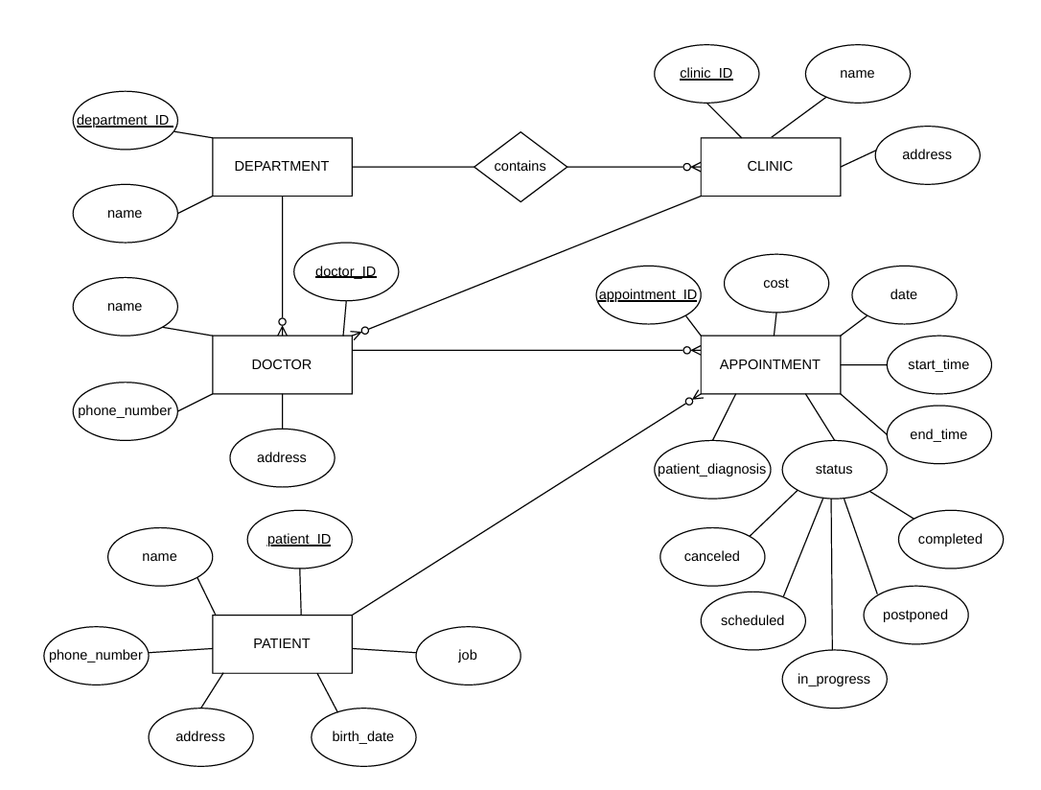

Relational Schema:
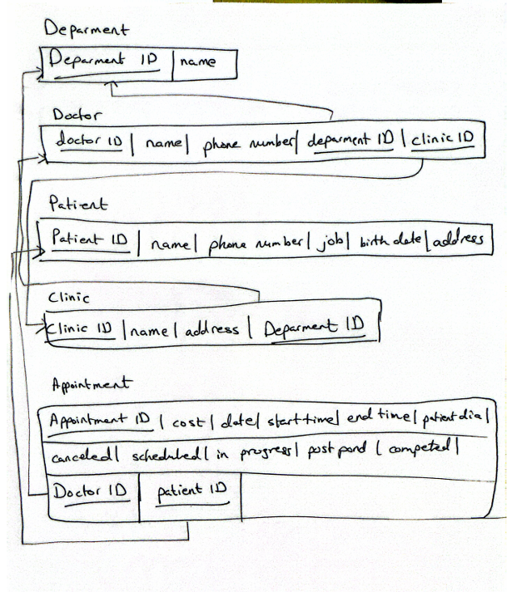

DDL & DML + Test Data:
DROP DATABASE clinic_management;
CREATE DATABASE clinic_management;
USE clinic_management;

CREATE TABLE Department (
department_id INT PRIMARY KEY,
name VARCHAR(100)
);

CREATE TABLE Clinic (
clinic_id INT PRIMARY KEY,
name VARCHAR(100),
address VARCHAR(200),
department_id INT,
FOREIGN KEY (department_id)
REFERENCES Department(department_id)
);

CREATE TABLE doctor (
doctor_id INT PRIMARY KEY,
name VARCHAR(100) NOT NULL,
address VARCHAR(200),
phone_number VARCHAR(20),
department_id INT,
clinic_id INT,
FOREIGN KEY (department_id) REFERENCES department(department_id),
FOREIGN KEY (clinic_id) REFERENCES clinic(clinic_id)
);

CREATE TABLE Patient (
patient_id INT PRIMARY KEY,
name VARCHAR(100),
phone_number VARCHAR(20),
address VARCHAR(200),
birth_date DATE,
job VARCHAR(100)
);

CREATE TABLE Appointment (
appointment_id INT PRIMARY KEY,
date DATE,
patient_id INT,
doctor_id INT,
start_time TIME,
end_time TIME,
cost DECIMAL(10,2),
status VARCHAR(20),
patient_diagnosis VARCHAR(255),

FOREIGN KEY (patient_id)
REFERENCES Patient(patient_id),

FOREIGN KEY (doctor_id)
REFERENCES Doctor(doctor_id)
);

INSERT INTO department (department_id, name) VALUES
(1, 'Cardiology'),
(2, 'Neurology'),
(3, 'Dermatology'),
(4, 'Orthopedics'),
(5, 'Pediatrics'),
(6, 'Ophthalmology'),
(7, 'ENT'),
(8, 'Urology'),
(9, 'Oncology'),
(10, 'Psychiatry');

INSERT INTO clinic (clinic_id, name, address, department_id)
VALUES
(101, 'Heart Clinic', 'Cairo', 1),
(102, 'Brain Clinic', 'Giza', 2),
(103, 'Skin Clinic', 'Alexandria', 3),
(104, 'Bone Clinic', 'Mansoura', 4),
(105, 'Kids Clinic', 'Tanta', 5),
(106, 'Eye Clinic', 'Cairo', 6),
(107, 'ENT Clinic', 'Giza', 7),
(108, 'Urology Clinic', 'Alexandria', 8),
(109, 'Cancer Care Clinic', 'Cairo', 9),
(110, 'Mental Wellness Clinic', 'Giza', 10);

INSERT INTO doctor (doctor_id, name, address, phone_number, department_id, clinic_id)
VALUES
(1001, 'Ahmed Ali', 'Cairo', '01012345678', 1, 101),
(1002, 'Sara Mohamed', 'Giza', '01198765432', 2, 102),
(1003, 'Omar Hassan', 'Alexandria', '01222222222', 3, 103),
(1004, 'Mona Adel', 'Mansoura', '01533333333', 4, 104),
(1005, 'Youssef Samy', 'Tanta', '01044444444', 5, 105),
(1006, 'Hany Mostafa', 'Cairo', '01087654321', 6, 106),
(1007, 'Aya Gamal', 'Giza', '01123456789', 7, 107),
(1008, 'Mahmoud Fathy', 'Alexandria', '01234567890', 8, 108),
(1009, 'Rania Khaled', 'Cairo', '01567891234', 9, 109),
(1010, 'Tamer Nabil', 'Giza', '01098765432', 10, 110);

INSERT INTO patient(patient_id, name, phone_number, address, birth_date, job)
VALUES
(2001, 'Mariam Ahmed', 'Cairo', '01055555555', '1999-05-10', 'Engineer'),
(2002, 'Ali Hassan', 'Giza', '01166666666', '2001-08-15', 'Student'),
(2003, 'Nour Mohamed', 'Alexandria', '01277777777', '1995-03-20', 'Teacher'),
(2004, 'Khaled Adel', 'Mansoura', '01588888888', '1988-11-01', 'Accountant'),
(2005, 'Salma Tarek', 'Tanta', '01099999999', '2003-07-25', 'Designer'),
(2006, 'Heba Ali', 'Cairo', '01111222333', '1998-01-18', 'Doctor'),
(2007, 'Mostafa Nasser', 'Giza', '01022334455', '1997-06-22', 'Pharmacist'),
(2008, 'Farah Samir', 'Alexandria', '01233445566', '2000-12-05', 'Teacher'),
(2009, 'Amr Youssef', 'Mansoura', '01544556677', '1994-09-14', 'Lawyer'),
(2010, 'Laila Mahmoud', 'Cairo', '01155667788', '2002-04-30', 'Student');

INSERT INTO appointment
(appointment_id, cost, date, start_time, end_time, patient_diagnosis, status, doctor_id, patient_id)
VALUES
(3001, 500.00, '2026-05-10', '10:00:00', '10:30:00', 'Fatty Liver', 'completed', 1001, 2001),
(3002, 350.00, '2026-05-11', '11:00:00', '11:20:00', 'Migraine', 'scheduled', 1002, 2002),
(3003, 450.00, '2026-05-12', '12:00:00', '12:40:00', 'Skin Allergy', 'in_progress', 1003, 2003),
(3004, 600.00, '2026-05-13', '13:00:00', '13:45:00', 'Bone Fracture', 'postponed', 1004, 2004),
(3005, 300.00, '2026-05-14', '14:00:00', '14:25:00', 'Flu', 'completed', 1005, 2005),
(3006, 400.00, '2026-05-15', '09:00:00', '09:30:00', 'Eye Infection', 'completed', 1006, 2006),
(3007, 350.00, '2026-05-16', '10:15:00', '10:45:00', 'Sinusitis', 'scheduled', 1007, 2007),
(3008, 550.00, '2026-05-17', '11:30:00', '12:00:00', 'Kidney Stones', 'completed', 1008, 2008),
(3009, 800.00, '2026-05-18', '12:30:00', '13:15:00', 'Cancer Screening', 'in_progress', 1009, 2009),
(3010, 450.00, '2026-05-19', '14:00:00', '14:30:00', 'Anxiety Disorder', 'completed', 1010, 2010);

SELECT p.name
FROM patient p
JOIN appointment a ON p.patient_id = a.patient_id
WHERE a.patient_diagnosis = 'Fatty Liver'
AND a.date >= DATE_SUB(CURDATE(), INTERVAL 1 YEAR);

SELECT c.address
FROM clinic c
JOIN department d ON c.department_id = d.department_id
WHERE d.name = 'Cardiology';

SELECT SUM(cost) AS total_paid
FROM appointment
WHERE patient_id = 12527
AND date >= DATE_SUB(CURDATE(), INTERVAL 3 YEAR);

DELETE FROM Appointment
WHERE appointment_id = 3005;

Explanation:
The database was created using a relational structure to organize clinic data and reduce repeated information.
Separate tables were made for Department, Clinic, Doctor, Patient, and Appointment to keep the data organized and easy to manage.
Primary keys were added to each table so every record has a unique ID. Foreign keys were used to connect the tables and keep relationships correct between them.
Different data types were used depending on the information stored. VARCHAR was used for text like names and addresses, DATE for birth and appointment dates, TIME for appointment times, and DECIMAL for cost values.
The NOT NULL constraint was applied to doctor names to make sure every doctor record has a valid name.
Sample data was inserted into all tables to test the database and make sure everything works properly.
The Appointment table stores important details such as date, time, diagnosis, status, and cost of each appointment.
SQL queries were used to perform tasks like finding patients with a specific diagnosis, getting clinic addresses by department, and calculating total payments for a patient.
Date functions like CURDATE() and DATE_SUB() were used to filter results based on time automatically.
The database is designed in a flexible way, so it can be expanded later to include features like prescriptions, billing, or medical records without changing the main structure.

Questions:
1.How would you prevent two appointments for the same doctor from overlapping? Outline the constraint or trigger logic.
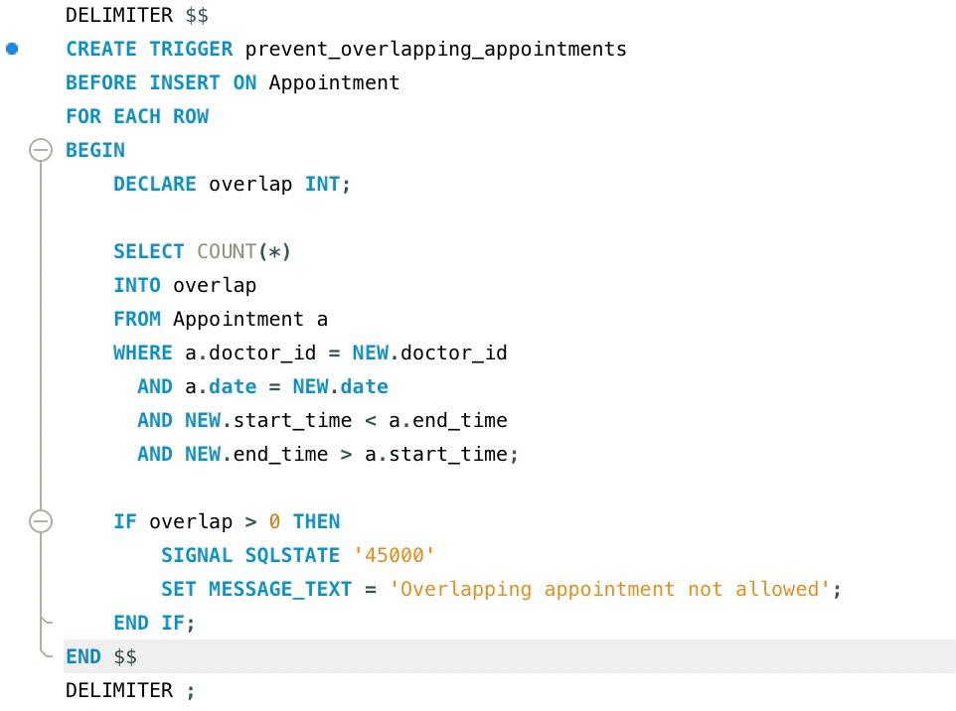

2.Describe a query to fetch each patient's detail and their appointments.
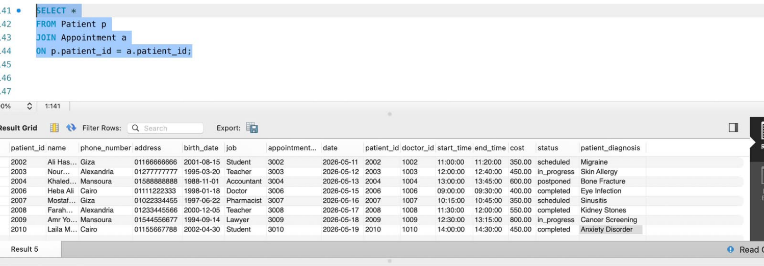
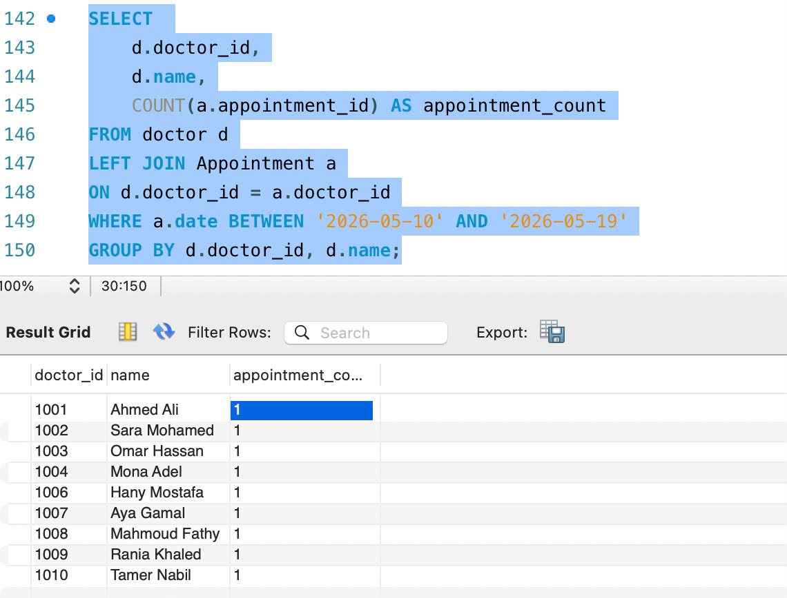
3.You need a view showing each doctor's upcoming appointment count for next month. What would its GROUP BY look like?

